1. Dropout at each fully connected layer:

|  |  |  |  |  |  |
| --- | --- | --- | --- | --- | --- |
| File_name | ‘modified’ |  |  |  |  |
| Method | Dropout | No dropout | Momentum on GB | Cross-validation | |
| EPOCHs | 20 | 20 | 10 | 20 | 30 |
| Time | 932.78 s | 858.61 |  | 857.02(14 epochs) |  |
| Accuracy: validation | 0.984 | 0.981 | 0.065 | 0.877 | 0.91 |
| Accuracy: test | 0.935 | 0.912 | -- | 0.755 | 0.012 |

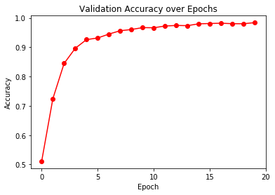

Figure 1 Dropout

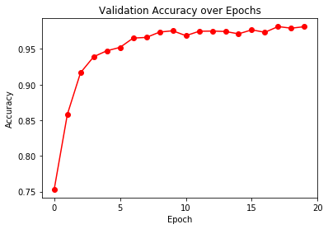

Figure 2 No-Dropout

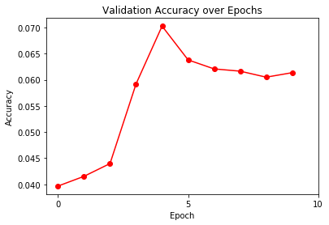

Figure 3 Momentum

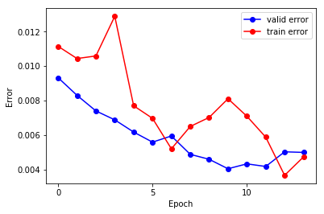

Figure Error: Cross validation

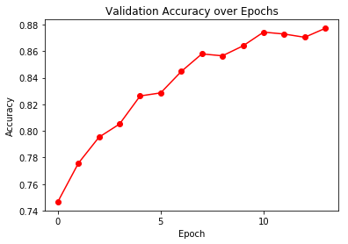

Figure Accuracy: cross validation